Group 2

GlobalTech Small Business Network Project
Switching Team Report
VLAN CREATION | ACCESS-PORT ASSIGNMENT | 802.1Q TRUNKING

Prepared by: UBANWOKE BLESSING CHIDINMA
HAMZAT HABEEB ADEYEMI
SALAMI TAJUDEEN ADESHINA
BARUWA AYOMIDE
ODIGIE MARVELOUS (MR)

Device: GlobalTech_Switch
(Cisco Catalyst 2960 or equivalent)

Date:
29 September 2026

1. Objective and Scope
Group 2 is responsible for the Layer 2 design of the shared GlobalTech network. Our required outcome is to create VLANs 10, 20, 30, 40 and 99, assign the user-facing switch ports to the correct VLANs, configure the router-facing link as an 802.1Q trunk, verify VLAN membership and trunk operation, and document every department-to-port assignment.
This report records what was configured, the evidence captured from the switch, and the points that still need attention before handover to Group 3 (Routing Team). It is deliberately specific about what the screenshots prove. A note on constraints: no router was supplied for this lab, so trunk operation and inter-VLAN connectivity could not be tested by our team.

2. VLAN Plan
The VLAN IDs, department names and addressing below come from the project requirements. The gateway address on each VLAN is reserved for the router subinterface configured by Group 3.
VLAN | Department | Network | Default Gateway
10 | ADMIN | 192.168.10.0/24 | 192.168.10.1
20 | STAFF | 192.168.20.0/24 | 192.168.20.1
30 | GUEST | 192.168.30.0/24 | 192.168.30.1
40 | IT | 192.168.40.0/24 | 192.168.40.1
99 | MANAGEMENT | 192.168.99.0/24 | 192.168.99.1

3. VLAN Creation and Verification
All five VLANs exist on the switch and show as active in the output below. Ports Fa0/9 to Fa0/48 and both Gigabit uplinks remain in the default VLAN 1, which is expected at this stage because they are not yet assigned to a department or to the trunk.
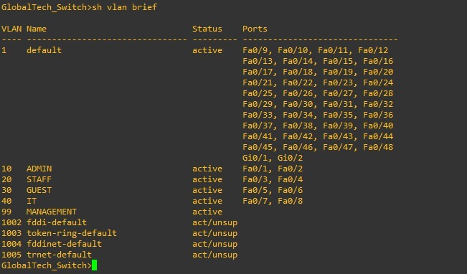
Figure 1: show vlan brief on GlobalTech_Switch

4. Access-Port Assignment
Two access ports were assigned to each department using interface ranges. Each range was set to access mode before the VLAN was applied.
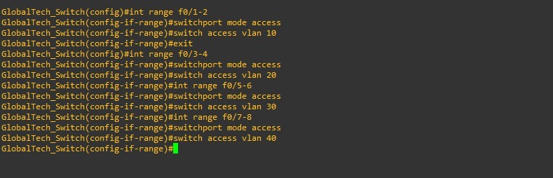
Figure 2: Access-port configuration by interface range
The resulting department-to-port assignment is documented below.
VLAN | Department | Ports | Mode
10 | ADMIN | Fa0/1 – Fa0/2 | Access
20 | STAFF | Fa0/3 – Fa0/4 | Access
30 | IT (named GUEST at time of capture) | Fa0/5 – Fa0/6 | Access
40 | GUEST (named IT at time of capture) | Fa0/7 – Fa0/8 | Access
99 | MANAGEMENT | No user ports | Switch management SVI only

The interface status output confirms that each port sits in the intended VLAN.
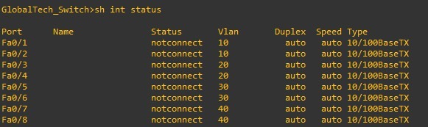
Figure 3: show interfaces status for Fa0/1 – Fa0/8
All eight ports report notconnect. That is consistent with the assignment being correct but tells us nothing yet about end-device connectivity, because no PCs were attached when these captures were taken. Live connectivity is a separate check, covered in Section 6.

5. 802.1Q Trunk to the Router
Limitation: no router was available for this lab
A router was not provided, so the trunk could not be brought up or tested end to end.

6. Switch Virtual Interfaces and Observations
The switch also carries SVIs for the department VLANs and the management VLAN. Figures 4 and 5 show how they were entered and their resulting state.
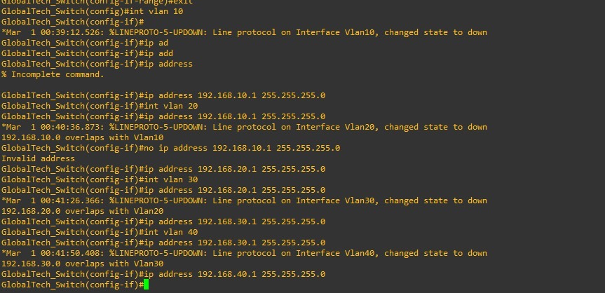
Figure 4: SVI configuration session, including overlap warnings
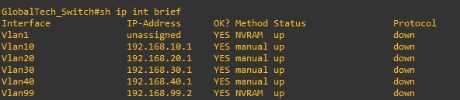
Figure 5: show ip interface brief
Two things stand out in Figure 5. First, every VLAN interface shows protocol down. That is expected here: an SVI stays down until at least one port in its VLAN is active, and all access ports are currently notconnect with no trunk up. Second, Vlan99 holds 192.168.99.2, which was set by Group 1 and is the correct management address on the 192.168.99.0/24 network, leaving .1 for the router.

7. Issues Identified and Corrective Actions
Issue | Impact
Trunk cannot be verified (no router provided) | Trunk operation and inter-VLAN routing cannot be demonstrated
No end devices tested | Port assignment proven, connectivity not

8. Handover to Group 3 (Routing Team)
- VLANs 10, 20, 30, 40 and 99 exist on the switch, with access ports Fa0/1 – Fa0/8 assigned as documented in Section 4.

9. Conclusion
Group 2 has completed VLAN creation and access-port assignment, and the evidence supports both. Because no router was provided, trunk operation and inter-VLAN connectivity remain unverified, and we have recorded that as a limitation of the lab rather than a completed check. Once a router is available, the switch is ready for Group 3 to begin inter-VLAN routing.

